**Exercise 1**: Setting Up JUnit

Scenario:

You need to set up JUnit in your Java project to start writing unit tests.

Steps:

1. Create a new Java project in your IDE (e.g., IntelliJ IDEA, Eclipse).

2. Add JUnit dependency to your project. If you are using Maven, add the following to your

pom.xml:

<dependency>

<groupId>junit</groupId>

<artifactId>junit</artifactId>

<version>4.13.2</version>

<scope>test</scope>

</dependency>

3. Create a new test class in your project.

**Solution:**

First,open IntelliJ IDE and create a new Java Project.

Next Add dependencies in pom.xml file

**Pom.xml:**

<?xml version="1.0" encoding="UTF-8"?>  
<project xmlns="http://maven.apache.org/POM/4.0.0"  
 xmlns:xsi="http://www.w3.org/2001/XMLSchema-instance"  
 xsi:schemaLocation="http://maven.apache.org/POM/4.0.0 http://maven.apache.org/xsd/maven-4.0.0.xsd">  
 <modelVersion>4.0.0</modelVersion>  
  
 <groupId>org.example</groupId>  
 <artifactId>JUnit_Setup</artifactId>  
 <version>1.0-SNAPSHOT</version>  
  
 <properties>  
 <maven.compiler.source>17</maven.compiler.source>  
 <maven.compiler.target>17</maven.compiler.target>  
 <project.build.sourceEncoding>UTF-8</project.build.sourceEncoding>  
 </properties>  
  
 <dependencies>  
 <dependency>  
 <groupId>junit</groupId>  
 <artifactId>junit</artifactId>  
 <version>4.13.2</version>  
 <scope>test</scope>  
 </dependency>  
  
 </dependencies>  
  
  
</project>

Next create Java class.

**Calculator.java:**

package org.example;  
  
  
public class Calculator {  
  
 public int add(int a, int b) {  
 return a + b;  
 }  
  
 public int subtract(int a, int b) {  
 return a - b;  
 }  
  
 public int multiply(int a, int b) {  
 return a * b;  
 }  
  
 public int divide(int a, int b) {  
 if (b == 0) {  
 throw new IllegalArgumentException("Cannot divide by zero");  
 }  
 return a / b;  
 }  
}

Create a test class.

**Calculatortest.java:**

package org.example;  
  
import org.junit.Test;  
import static org.junit.Assert.*;  
  
  
public class CalculatorTest {  
  
 @Test  
 public void testAdd() {  
 Calculator calc = new Calculator();  
 *assertEquals*(8, calc.add(5, 3));  
 }  
  
 @Test  
 public void testSubtract() {  
 Calculator calc = new Calculator();  
 *assertEquals*(2, calc.subtract(5, 3));  
 }  
  
 @Test  
 public void testMultiply() {  
 Calculator calc = new Calculator();  
 *assertEquals*(15, calc.multiply(5, 3));  
 }  
  
 @Test  
 public void testDivide() {  
 Calculator calc = new Calculator();  
 *assertEquals*(2, calc.divide(6, 3));  
 }  
  
 @Test(expected = IllegalArgumentException.class)  
 public void testDivideByZero() {  
 Calculator calc = new Calculator();  
 calc.divide(5, 0); // Should throw exception  
 }  
}

Now run the program from the test file.

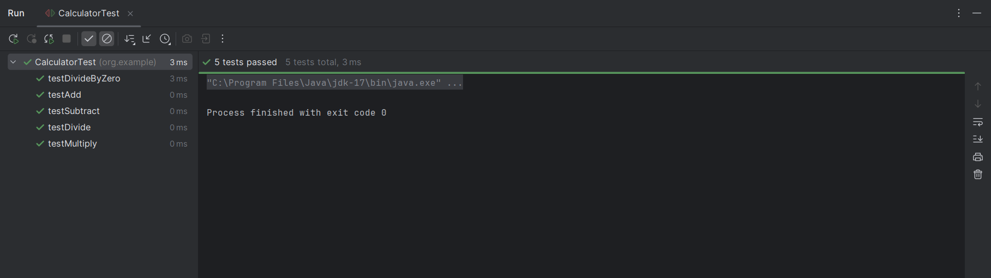**Output:**